# Inserting a Header or a Footer

Insert a predefined header or footer

1. On the **Insert** tab, in the **Header & Footer** group, click **Header** or **Footer**.

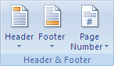

1. Click the header or footer design that you want.

 NOTE   If you don't see a gallery of header or footer designs, there might be a problem with the Building Blocks template on your computer

The header or footer is inserted on every page of the document.

 NOTES

* If necessary, you can format the text in the header or footer by selecting the text and using the formatting options on the Mini toolbar, which is a part of the Microsoft Office Fluent interface.
* If you want to switch to a different predefined header or footer, repeat these steps, and choose a different header or footer from the gallery.

Insert a custom header or footer

1. On the **Insert** tab, in the **Header & Footer** group, click **Header** or **Footer**.



1. Click **Edit Header** or **Edit Footer**.
2. Type text or insert graphics and other content by using the options in the **Insert** group on the **Design** tab, under the **Header & Footer Tools** tab.

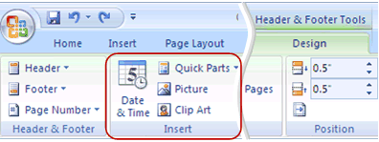

 TIP   To save the header or footer that you created to the gallery of header or footer options, select the text or graphics in the header or footer, and then click **Save Selection as New Header** or **Save Selection as New Footer**.